County Councillor Update  Coker Division SCC  Cllr Mark Keating  October 2021 |  | 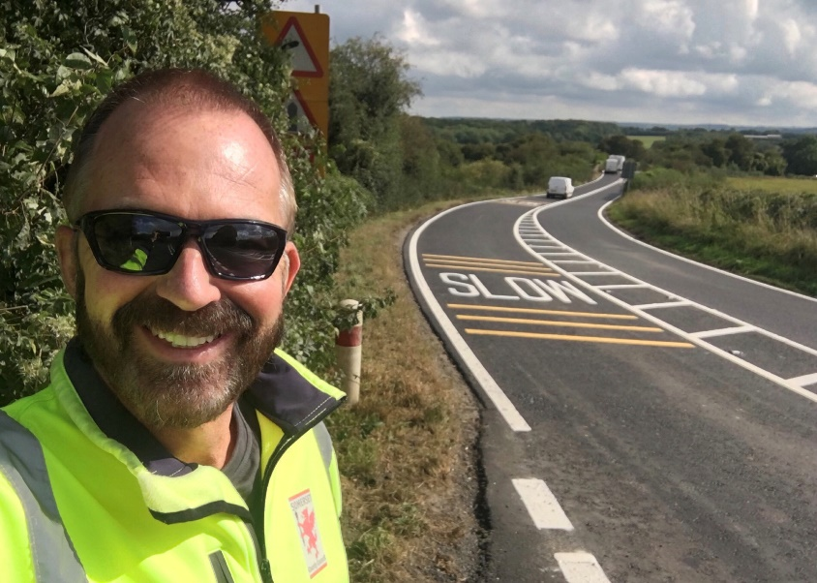
Representing you in - Barwick, Chiselborough, Closworth, East Chinnock, East Coker, Hardington Manderville, Hardington Marsh, Hardington Moor, Haselbury Plucknett, Middle Chinnock, Montacute, North Coker, North Perrott, Norton Sub Hamdon, ​Odcombe, Pendomer, Sutton Bingham, Stoford, West Chinnock, West Coker.
Useful Contacts Resources and Websites: Somerset Coronavirus Support Helpline: 0300 7906275
Cllr Mark Keating – Somerset County Council | E: MAKeating@Somerset.gov.uk | M: 07767 203968
South Somerset Area Highways Office | E: countyroads-southsom@somerset.gov.uk | T: 0300 123 2224
Report Pothole/Road Defect | E: roadsandtransportSD@somerset.gov.uk | T: 0300 123 2224
Report Dead Animal/Mud on Road | E: roadsandtransportSD@somerset.gov.uk | T: 0300 123 2224
Neil McWilliams – Highways Service Manager | E: countyroads-southsom@somerset.gov.uk | T: 0300 123 2224
Lee Norman/Derek Davies – Assist Highways Service Manager | E: countyroads-southsom@somerset.gov.uk | T: 0300 123 2224
Garry Warren/Rebecca Vaughan – Traffic Engineer. Traffic & Transport Development | E: countyroads-southsom@somerset.gov.uk | T: 0300 123 2224
Gully Emptying / Road Sweeper | E: chris.holley@southsomerset.gov.uk | T: 01935 462462
Ranger Scheme |  | T: 01935 462462
Road Records & Highway Licensing | E: Roadrecords@Somerset.gov.uk | T: 0300 123 2224

Report Adult at Risk | adults@somerset.gov.uk |  |  | T: 0300 123 2224  T: Emergency: 999
Report Child at Risk | childrens@somerset.gov.uk |  |  | T: 0300 123 2224  T: Emergency: 999
Children’s Social Care Worker out of hours Emergency Duty Team |  |  |  | T: 0300 123 2327
Fostering and Adoption www.fosteradoptsomerset.org.uk | AandFRecruitmentEnquiryLine@somerset.gov.uk |  |  | T: 0800 587 9900
www.somersetwaste.gov.uk |  | ssdc@southsomerset.gov.uk | T: 01935 462462
https://www.travelsomerset.co.uk/ |  | Travel - Drive Bus Train Walk Cycle Weather
www.somerset.gov.uk |  | generalenquiries@somerset.gov.uk | T: 0300 123 2224
http://roadworks.org/ |  | Useful website for road works info
www.facebook.com/somersetcountycouncil |  | Somerset County Council Facebook page
https://roam.somerset.gov.uk/roam/map |  | Interactive Rights of Way Map / maintenance reporting
Chinnock Hollow: I updated adjacent parish councils regarding closure and works/survey of Chinnock Hollow.
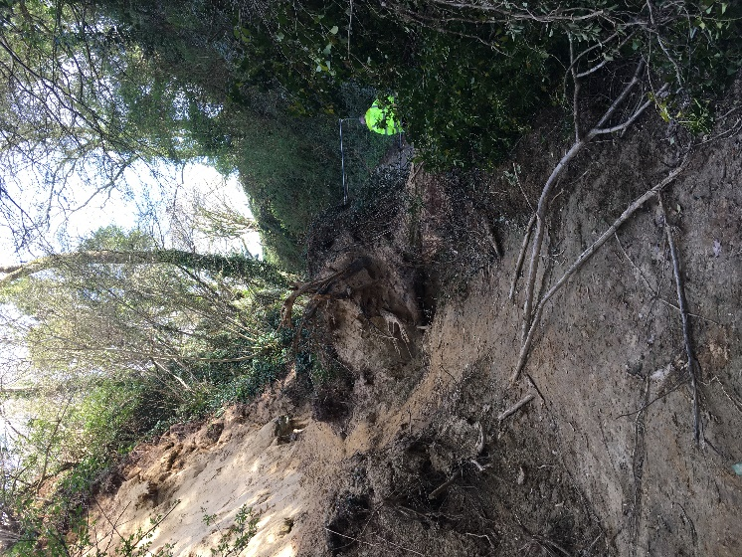
I have met on-site with councillors from adjacent parish councils with Officers in recent months and had some very useful conversations. Contractor specialising in land slip surveying were appointed in Spring this year, unfortunately due to Pandemic restrictions, work backlogs and other resource/staffing issues there has been a much longer than usual wait for this survey to be started.
My apologies for delays which are beyond our control. I know Officers share the frustrations of local residents and those who use the hollow on a regular basis. I can confirm the survey team’s on-site/start date is now confirmed as the 18th of October. Initial investigation works will involve vegetation clearance and inspections, with the ecological works undertaken in between. At this stage we do not have an indication as to how long this stage will last. The team will submit an options report to Somerset County Highways in the weeks following and I will update you as soon as further information is available to me.
I just want to assure you that the importance of the road is understood. Safety must come first I am sure you agree and that this safety audit must be completed before we can consider any necessary works that might be required prior to re-opening the road.
I have a meeting next week on-site with the Director of Somerset Highways. As soon as there is further information, I will update parish councils. Please do also share with residents in your local communities
West Coker (A30) resurfacing 2022: is to be fully resurfaced in 2022 with extensive weeks lasting a number of weeks. I have discussed with Somerset County Highways the important considerations/issues and agreed a comprehensive plan for traffic management that will include proactive weekly communications with residents and parish council and neighbouring parish councils. As site kiosk will be opened during the works to allow residents to drop-in with any concerns, or to flag-up any issues/concerns/complaints directly with contractors. We discussed and agreed that leafletting of homes will be included as part of best managing local expectations/communications and contractors will be available to attend PC meetings in West Coker also. It is agreed that roadworks signage/diversion signage must be effective and deliver the best possible driving experiences during works. I have also been robust in making it clear that the works at Chinnock Hollow must be completed without further delay, so we can ensure West Coker can proceed in August 2022 as planned.
A30 Road Closure Traffic Management Planning: I have recently held a meeting with strategic planners with regard to the vital importance for putting in place a revised plan for when utility companies or County Highways require that the A30 is subject to a Temporary Traffic Regulation Order (TTRO) - either closed completely, or operating on stop-n-go for maintenance/emergency works. Issues discussed include, better/more effectively posted/positioned diversion routes, better communication/information sharing with online roadworks information platforms such as www.streetworks.org www.one.network and www.travelsomerset.co.uk effective positioning of road signage, the need to barrier-off and provide detail of exact location of closure to traffic when road is fully closed. The lack of ‘business open as usual’ signage was discussed and included in the planning.

Sutton Bingham Reservoir: I met with County Highways Officers in September with regard to issues of speed in an area where many drivers stop to feed the ducks, take in the views over the water, or just a place to eat their lunch. Wessex Water are currently undertaking on-site enhancements to buildings and structures to facilitate an enhanced customer/visitor experiences on the grassed areas, viewing points, birdwatching hides and play 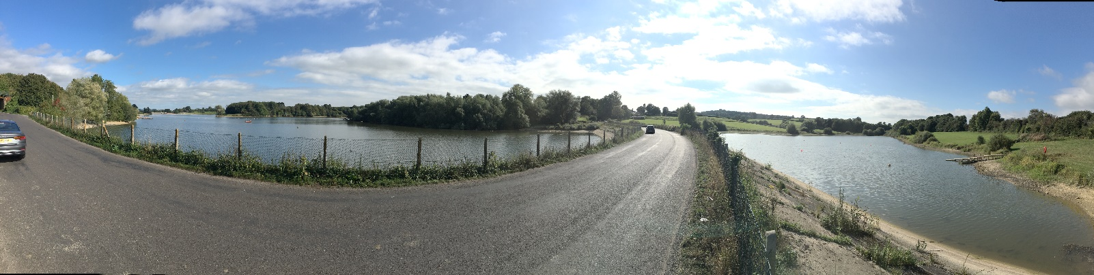equipment. I pleased that County Highways will be drawing up plans to put in place on-road/causeway parking bays with enhanced/additional signage to encourage adherence to the 30mph speed limit through this section and provide improved/clearer opportunities for those using this amenity. I am hoping to discuss further with Closworth Parish and local residents soon.
Coronavirus infection rates: As of 30th September, the number of confirmed Covid cases in Somerset was 42,800 (26.6% up from 33,812 on 29th August) and the number of Covid-attributed deaths 839. The rate per 100,000 stands at 320.2 (459.1) for Somerset with Mendip at 379.8 (358.2), Sedgemoor at 292.3 (673.0), South Somerset 298.2 (410.5) and SW&T at 321.7 (417.1). The number of total deaths across the County is currently 15% below the 5-year average and the latest R-value for Somerset is between 0.7 and 0.9.
Infection rates in Somerset continue to be high. It is therefore important even for those who have had both jabs to remember to observe Social Distancing and to Ventilate indoor areas at all times.

Somerset Coronavirus Support Helpline: A single phone number continues to be available for anyone in Somerset who needs Coronavirus-related support. 0300 790 6275, is open seven days a week from 8am to 6pm.
Vaccination programmes roll-out: Somerset continues to have one of the highest vaccination rates in the country with the latest figures showing over 95% of the adult population having had one dose of vaccine and 90.2% having had both doses. Work is now focusing on Children aged 12-15 years old via the school’s immunization service and the third booster jab which is due 6 months after the second.
Local Government Reorganisation: Following the Secretary of State for Housing, Communities and Local Government (MHCLG) decision to support the move to a single Unitary Council across Somerset the transition programme, lead teams and governance structure have been agreed by the five current Councils. On 17th September the Councils responded to the Governments request to look at possible ward boundary changes with a maximum of 85 Unitary Councillors being elected. Whilst a number of options were presented it was almost universally felt that these gave sub-optimal outcomes at such an important stage. A cross-party and cross-authority request was therefore also submitted requesting more time, more flexibility in the warding parameters and involvement of the Local Govt Boundary Commission ahead of a Unitary election. It is still expected that statutory orders will be laid before Parliament in the late Autumn and a vesting date of the new authority as April 2023.
Somerset LGR Conference: The first Town, Parish and City conference focussing on Local Government Re-organisation in Somerset is due to take place on 7th October with over 100 different Councils already signed up to attend. The one-day conference will give Councils the opportunity to hear first-hand the transition programme and input their own thought on how the move to a Unitary structure could develop.
Somerset Youth Parliament: Somerset’s Youth Parliament is seeking nominations from young people aged 11 to 18 wishing to become a Member of Youth Parliament (MYP). Nationally, over 300 elected representatives work with central and local government to make sure young people’s voices are heard. Supported by Somerset County Council, Somerset MYPs campaign on a range of issues, advise, represent, give grants and are consulted by decision makers. 11- to 18-year-olds who live in or attend school or college in Somerset can put themselves forward to be the county’s next MYPs. To do this, they should complete a short online form available here www.somerset.gov.uk/myp by Friday 5 November. Elections and voting will take place in December 2021 with newly elected MYPs taking up office on 1 March 2022 and serving a two-year term.
Young People’s views on climate change: 11 to 18-year-olds in Somerset are invited to attend two virtual events in October to help shape Somerset County Council’s Climate Emergency Strategy. Somerset Youth Parliament is running two free sessions via Zoom on Monday 11 and Monday 18 October, 6.15pm to 8pm, to learn more about the county’s plans, listen to key speakers including Rebecca Pow MP (Parliamentary Under Secretary of State at the Department for Environment, Food and Rural Affairs) and have an opportunity to ask questions and contribute their own thoughts and ideas. To book a place at one of the virtual events email Kate Darlington at: kdarlington@somerset.gov.uk
Applications for school places 2022: Foe all children moving from primary to secondary school, or middle to upper school, in September 2022 applications for secondary school places opened on 13th September 2021 and must be submitted before Sunday 31 October 2021. All children starting school for the first time in September 2022, as well as those moving between infant and junior or first and middle school applications must be submitted between Monday 27 September 2021 and Saturday 15 January 2022. www.somerset.gov.uk/admissions
National Award (1): SCC has won a prestigious national award in recognition of its ground-breaking work in supporting the set-up microbusinesses. Leading local government publication the MJ awarded Somerset an achievement award in the Delivering Better Outcomes category, for its Community Micro-enterprise project. This supports Micro-providers who then provide help and support on the ground in local communities for people who need it.
National Award (2): Ann Adams, Service Manager at Somerset County Council’s Support Services for Education (SSE), was a finalist in the outstanding lead governance professional category at the National Governance Association’s (NGA) Outstanding Governance Awards 2021.The category recognises individuals leading and managing governance across several schools.

